|  |  |  |  |  |  |
| --- | --- | --- | --- | --- | --- |
| Description | Current | Change | Recommended | Allocation | ICR |
| BT Panorama Super | | | | | |
| Investment number one | $988 | $988 | $0 | 91.65% | 1.50% |
| Investment number three | $90 | $90 | $0 | 8.35% | 4.50% |
| BT Panorama Super | $1,078 | $1,078 | $0 |  |  |
| BT Panorama Super | | | | | |
| Investment number two | $0 | $60,000 | $60,000 | 30.00% | 0.00% |
| Investment number one | $0 | $50,000 | $50,000 | 25.00% | 1.50% |
| Investment number two | $0 | $86,000 | $86,000 | 43.00% | 0.00% |
| Investment number four | $0 | $4,000 | $4,000 | 2.00% | 0.00% |
| BT Panorama Super | $0 | $200,000 | $200,000 |  |  |
| BT Panorama Super | | | | | |
| INVESTMENT 9 - OTHER | $0 | $1,000,000 | $1,000,000 | 100.00% | 0.00% |
| BT Panorama Super | $0 | $1,000,000 | $1,000,000 |  |  |
| Total | $1,078 | $1,201,078 | $1,200,000 |  |  |

|  |  |  |  |  |  |
| --- | --- | --- | --- | --- | --- |
| Description | Current | Change | Recommended | Allocation | ICR |

|  |  |  |  |
| --- | --- | --- | --- |
| Status | Current | Recommended | Recommended |
| Description | BT Panorama Super | BT Panorama Super | BT Panorama Super |
| Balance | $1,078 | $200,000 | $1,000,000 |
| One-off Fees Subheader |  |  |  |
| Ongoing Fees Subheader | | | |
| - Sliding Admin Fee | $0.00 (0.00%) | $200.00 (0.10%) | $350.00 (0.04%) |
| - Admin Fee (Flat) | $480.00 | $480.00 | $480.00 |
| - Admin Fee (Floating) | $5.39 (0.50%) | $0.00 (0.00%) | $0.00 (0.00%) |
| Subtotal | $485.39 | $200.00 | $350.00 |
| Adviser Fee (Flat) | None | None | None |
| Total | $485.39 (45.03%) | $200.00 (0.10%) | $350.00 (0.04%) |
| Comparative Total | $485.39 | $550.00 | |

|  |  |
| --- | --- |
| Status | Alternative |
| Description | BT Wrap |
| Balance | $34,743 |
| One-off Fees Subheader |  |
| Ongoing Fees Subheader | |
| - Admin Fee (Floating) | $173.72 (0.50%) |
| Subtotal | $173.72 |
| Adviser Fee (Flat) | None |
| Total | $173.72 (0.50%) |
| Comparative Total | $0.00 |

|  |  |  |  |
| --- | --- | --- | --- |
| - Consol Balance | $1,200,000 | $1,200,000 | $1,200,000 |
| Adviser Fee (Flat) | None | None | None |

|  |  |
| --- | --- |
| - Consol Balance | $1,200,000 |
| Adviser Fee (Flat) | None |

|  |  |  |  |
| --- | --- | --- | --- |
| Status | Current | Risk Profile | Variance |
| Defensive | | | |
| Cash | 0% | 0% | 0% |
| Fixed Interest | 0% | 90.00% | -90.00% |
| Subtotal | 0% | 90.00% | -90.00% |
| Growth Subheader | | | |
| Australian Equities | 0% | 10.00% | -10.00% |
| International Equities | 0% | 0% | 0% |
| Australian Listed Property | 0% | 0% | 0% |
| International Listed Property | 0% | 0% | 0% |
| Direct Property | 0% | 0% | 0% |
| Growth Subtotal | 0% | 10.00% | -10.00% |
| Alternative Subheader | | | |
| Alternatives | 0% | 0% | 0% |
| Alternative Subtotal | 0% | 0% | 0% |
| Total | 100.00% | 100.00% | 100.00% |

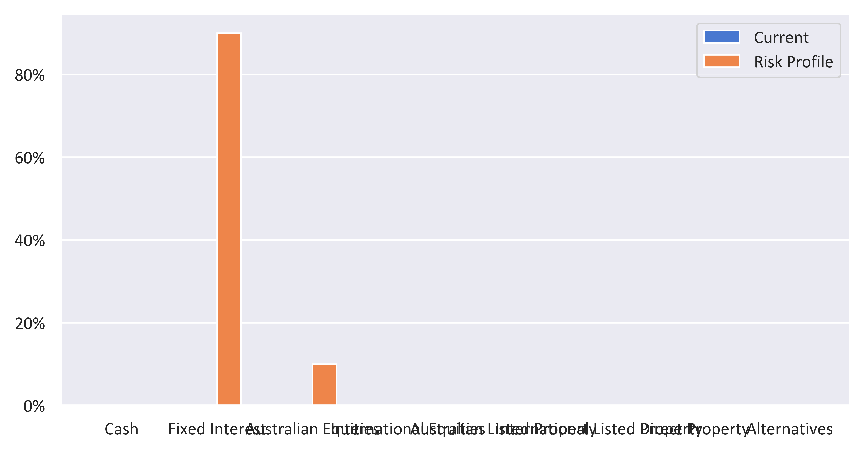

|  |  |  |  |
| --- | --- | --- | --- |
| Status | Recommended | Risk Profile | Variance |
| Defensive | | | |
| Cash | 0% | 0% | 0% |
| Fixed Interest | 0% | 90.00% | -90.00% |
| Subtotal | 0% | 90.00% | -90.00% |
| Growth Subheader | | | |
| Australian Equities | 0% | 10.00% | -10.00% |
| International Equities | 0% | 0% | 0% |
| Australian Listed Property | 0% | 0% | 0% |
| International Listed Property | 0% | 0% | 0% |
| Direct Property | 0% | 0% | 0% |
| Growth Subtotal | 0% | 10.00% | -10.00% |
| Alternative Subheader | | | |
| Alternatives | 0% | 0% | 0% |
| Alternative Subtotal | 0% | 0% | 0% |
| Total | 100.00% | 100.00% | 100.00% |

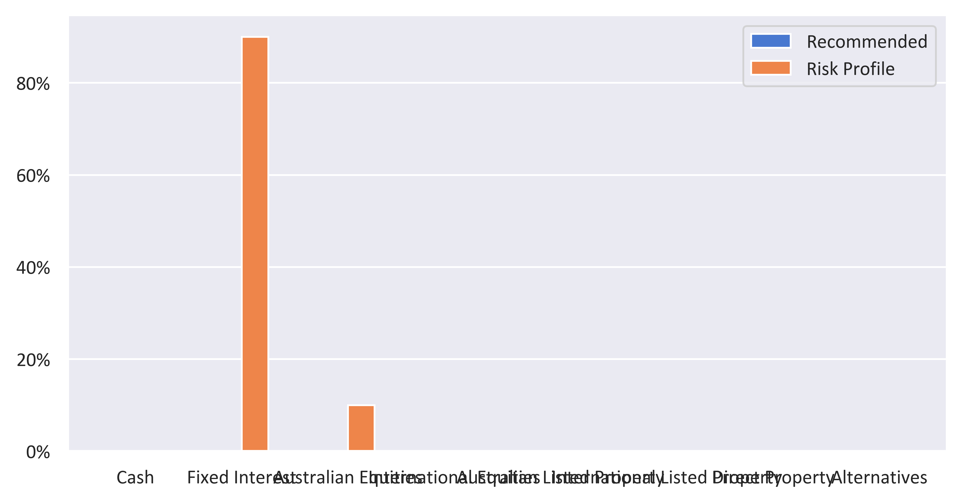

|  |  |  |  |  |
| --- | --- | --- | --- | --- |
| Status | Current | Risk Profile | Recommended | Variance |
| Defensive | | | | |
| Cash | 0% | 0% | 0% | 0% |
| Fixed Interest | 0% | 90.00% | 0% | -90.00% |
| Subtotal | 0% | 90.00% | 0% | -90.00% |
| Growth Subheader | | | | |
| Australian Equities | 0% | 10.00% | 0% | -10.00% |
| International Equities | 0% | 0% | 0% | 0% |
| Australian Listed Property | 0% | 0% | 0% | 0% |
| International Listed Property | 0% | 0% | 0% | 0% |
| Direct Property | 0% | 0% | 0% | 0% |
| Growth Subtotal | 0% | 10.00% | 0% | -10.00% |
| Alternative Subheader | | | | |
| Alternatives | 0% | 0% | 0% | 0% |
| Alternative Subtotal | 0% | 0% | 0% | 0% |
| Total | 100.00% | 100.00% | 100.00% | 0.00% |

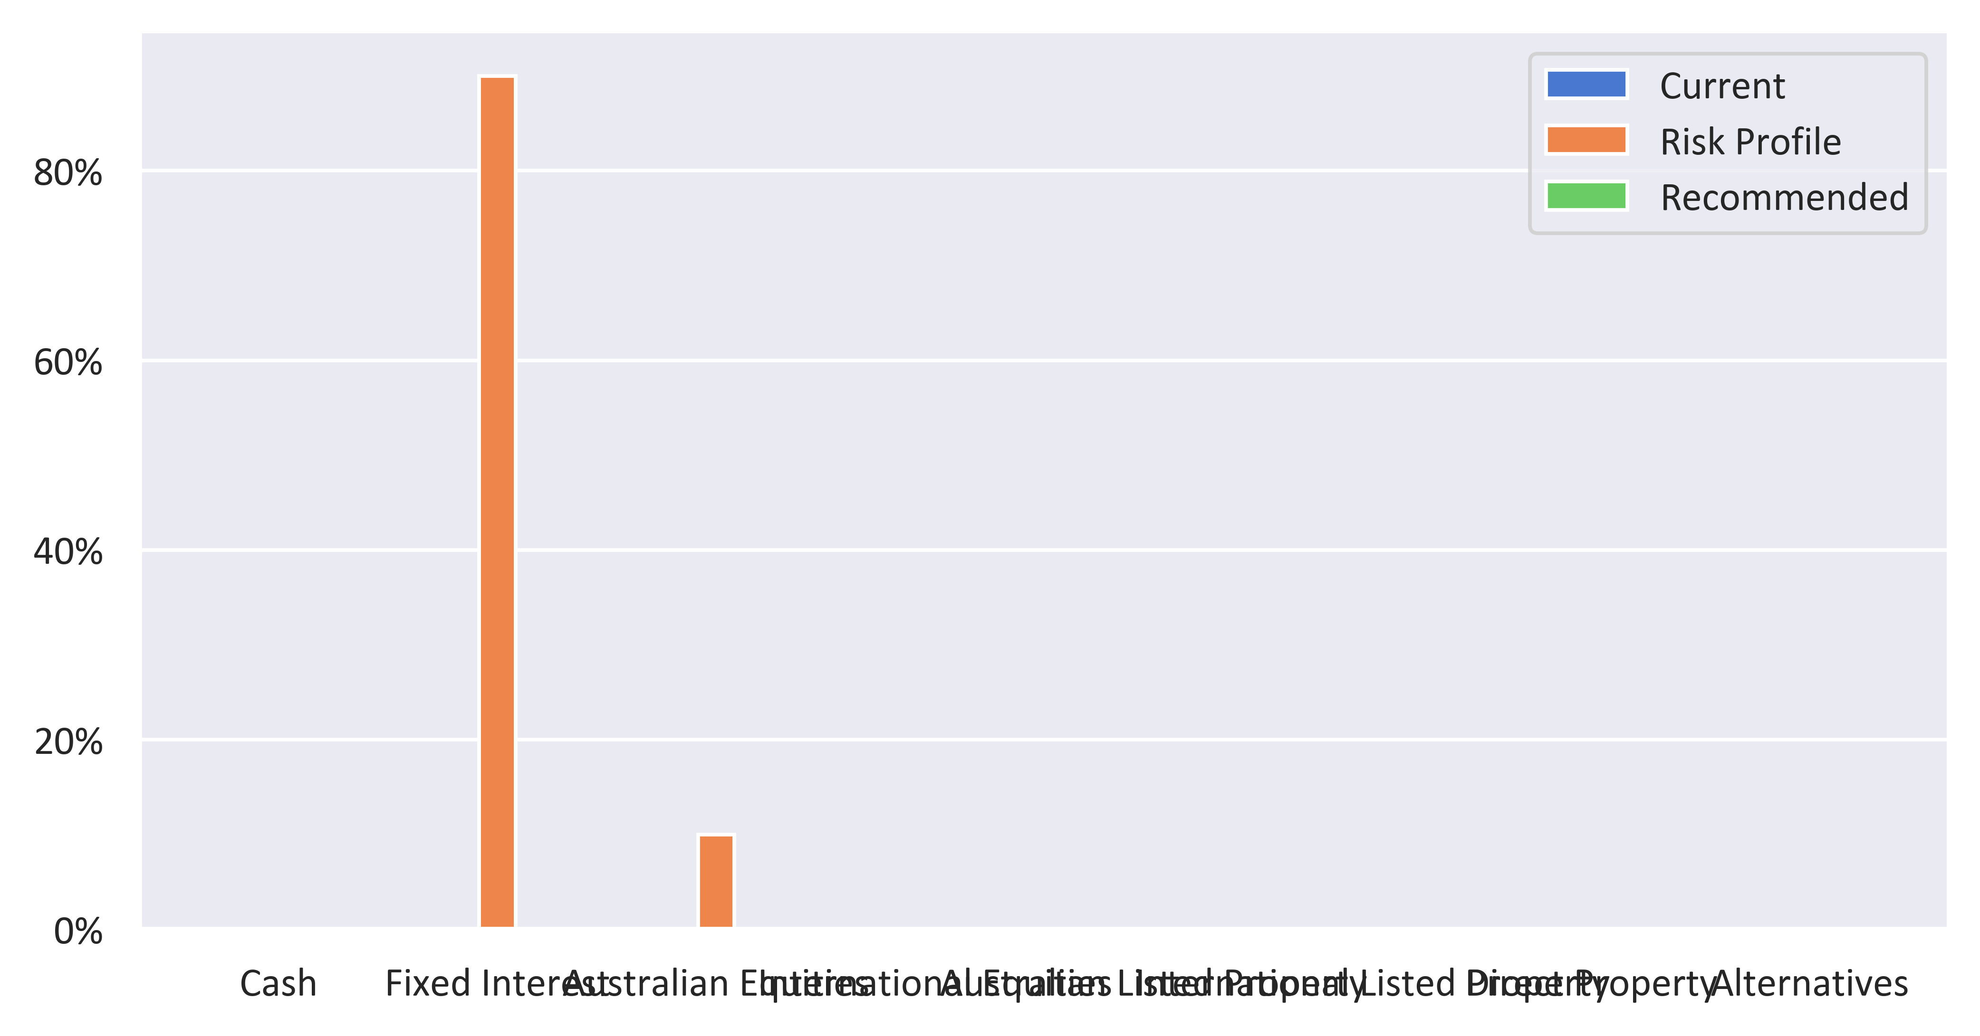

|  |  |  |  |
| --- | --- | --- | --- |
| Status | Current | Recommended | Variance |
| Defensive | | | |
| Cash | 0% | 0% | 0% |
| Fixed Interest | 0% | 0% | 0% |
| Subtotal | 0% | 0% | 0% |
| Growth Subheader | | | |
| Australian Equities | 0% | 0% | 0% |
| International Equities | 0% | 0% | 0% |
| Australian Listed Property | 0% | 0% | 0% |
| International Listed Property | 0% | 0% | 0% |
| Direct Property | 0% | 0% | 0% |
| Growth Subtotal | 0% | 0% | 0% |
| Alternative Subheader | | | |
| Alternatives | 0% | 0% | 0% |
| Alternative Subtotal | 0% | 0% | 0% |
| Total | 100.00% | 100.00% | 100.00% |

